IT2120 - Probability and Statistics – Lab Sheet 07

Exercise

1)

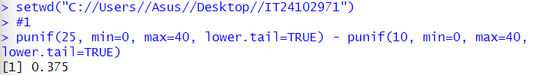

2)



3)

